|  |  |
| --- | --- |
| Transformacions | Igualtats de i |
|  |  |

|  |  |
| --- | --- |
| D-H | |
| |  |  |  |  |  | | --- | --- | --- | --- | --- | | Tx | Rx | Tz | Rz |  | |  |  |  |  | {0} → {1} | |  |  |  |  | {1} → {2} | |  |  |  |  | ... | | Regles per triar S.R.:   1. Identificar eixos d’actuació z 2. Identificar eixos x (distància mínima entre i ) 3. Assegurar que sigui perpendicular a i |

Momentos: 

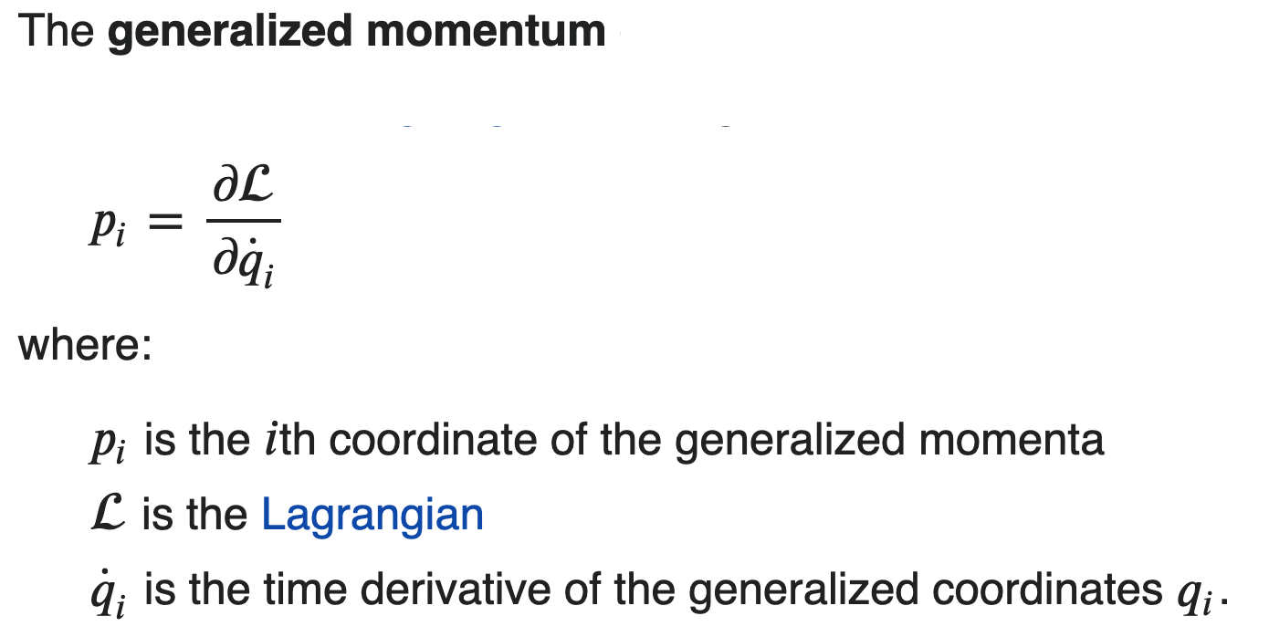

|  |  |
| --- | --- |
| ANGULAR | L |
| In [SI base units](https://en.wikipedia.org/wiki/SI_base_unit) | kg m2 s−1 |
| Formula | = r × p |

|  |  |
| --- | --- |
| LINEAR | p, p |
| [SI unit](https://en.wikipedia.org/wiki/SI_unit) | kg⋅m/s |
| Formula |  |

Fórmula Inverse Kinematics

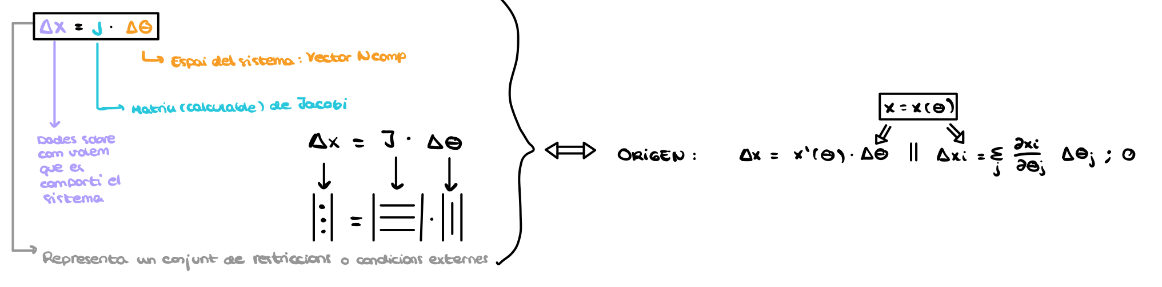

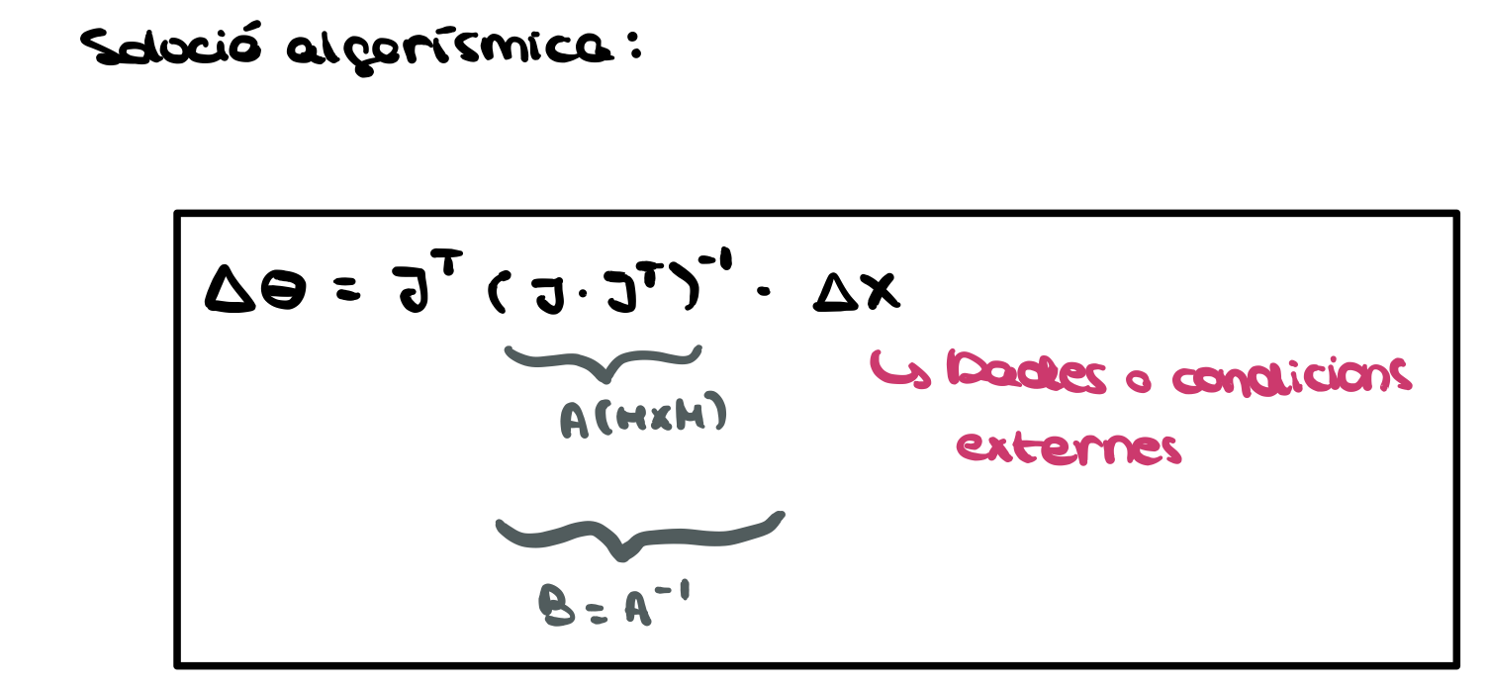

Ejercicio ejemplo jacobiano

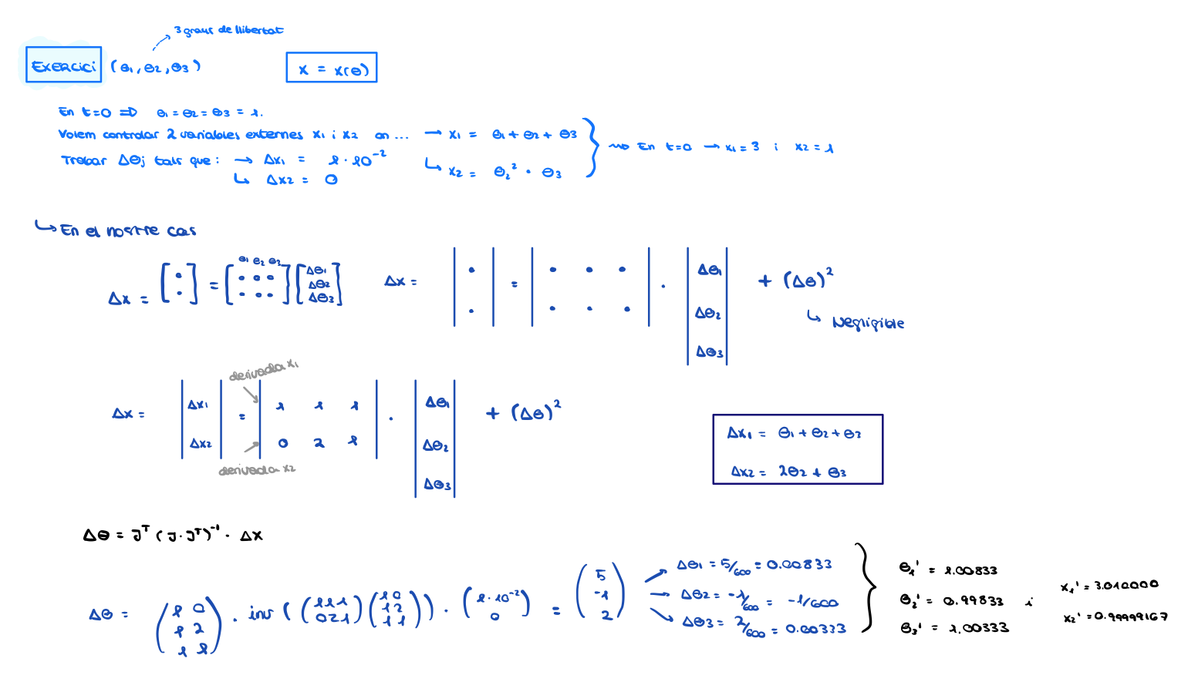

Energía cinética

Lagrange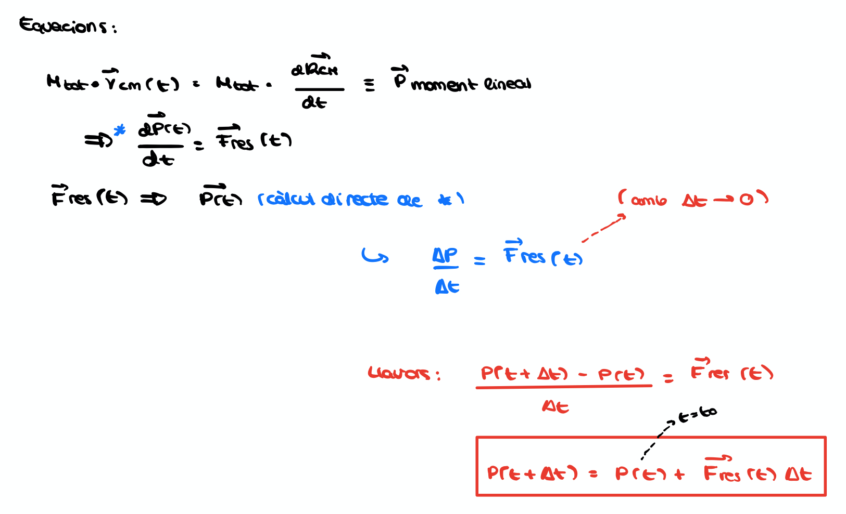

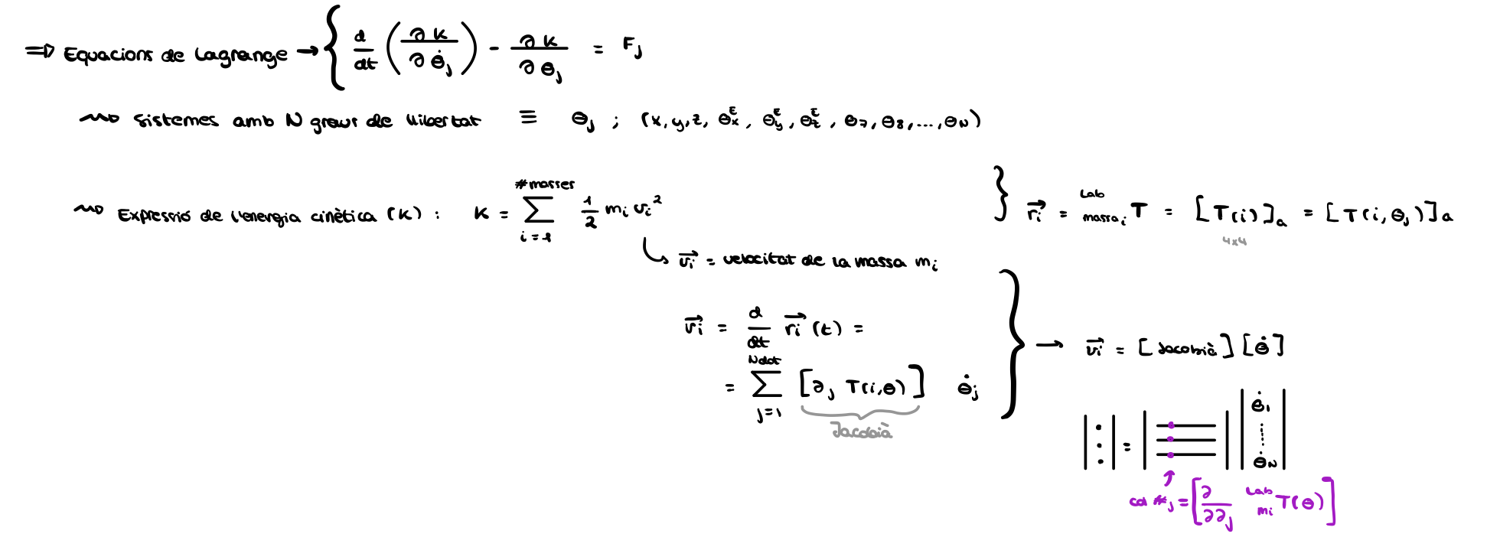

Derivadas

